Report by Arun Kumar
Linkedln:-https://www.linkedin.com/in/arunkumar9855/

Project Proposal: AI-Powered Customer Support Chatbot for Small-Scale Businesses
1. Problem Statement
Small-scale businesses, which often operate with limited staff and resources, struggle to provide efficient and timely customer support. This results in delayed responses, unsatisfactory customer experiences, and ultimately, the loss of potential business opportunities. With increased digital engagement, customers now expect immediate support, a service many small-scale businesses cannot provide without incurring high operational costs.

The proposed AI-powered chatbot will assist these businesses by automating customer service functions. The chatbot will handle FAQs, product inquiries, order status checks, and more, providing 24/7 support. This will improve customer satisfaction and loyalty while reducing the overhead of hiring and managing customer support teams.

2. Market/Customer/Business Need Assessment
Current Market Need
With over 400 million small and medium-sized businesses (SMBs) worldwide, the need for cost-effective, scalable customer support is critical. Customer support chatbots are already proving effective in the market:
30% of businesses have reported cost reductions from using chatbots, saving up to 30% on customer support cost .
77% of small businesses that adopt automation tools (like chatbots) have reported an increase in customer satisfaction.
Proof from the Market
Tars Chatbot Platform: Small businesses using Tars have seen a 30% increase in lead conversion rates due to their 24/7 support chatbot solutions. This highlights the real-world value of automating customer service with AI.
Intercom: A customer messaging platform that integrates chatbots for small businesses reported reaching $150 million in Annual Recurring Revenue (ARR) by 2020. A significant part of their success comes from small and medium businesses adopting their AI-powered support tools.
Future Need
The future of AI-powered chatbots is bright. According to Gartner, by 2030, 80% of all customer interactions will be managed without a human agent. With customer expectations evolving and the digital transformation of small businesses increasing, chatbots will be integral to business growth and customer retention. AI-driven customer engagement tools will remain critical in managing customer service, sales, and even personalized marketing in the long run.

Moreover, as AI technologies like Natural Language Processing (NLP) and Reinforcement Learning continue to evolve, the accuracy and versatility of chatbots will only improve. This ensures long-term viability and growth for businesses adopting these solutions today.

3. Target Specifications and Characterization
1. Automated Customer Support:
Handles frequently asked questions (FAQs), product recommendations, and order inquiries.
Reduces response time to zero, offering immediate answers 24/7.
2. 24/7 Availability:
Provides round-the-clock customer support, reducing the need for dedicated support teams.
3. Multilingual Support:
Integrates NLP tools to support multiple languages, making the chatbot accessible to a global customer base.
4. Scalability:
As the business grows, the chatbot can handle an increased volume of customer queries without additional staffing needs.
5. Personalized Customer Experience:
Uses AI to provide personalized responses based on previous interactions, increasing customer satisfaction and loyalty.
6. Easy Integration:
Can be deployed across various platforms including websites, mobile apps, and social media platforms like Facebook Messenger, WhatsApp, and more.
4. External Search (Information and Data Analysis)
Multiple credible sources confirm the effectiveness of AI chatbots for small businesses:
Gartner Research (2021): Predicts that AI will handle 80% of all customer interactions by 2030, especially for businesses with limited resources.
Forbes (2022): States that chatbots help small businesses reduce operational costs by up to 40% and improve customer engagement by offering 24/7 support.
Grand View Research (2023): Forecasts that the global chatbot market will grow at a CAGR of 24.9% from 2021 to 2028, reaching a market size of over $3.5 billion. This growth is driven largely by SMBs adopting chatbot technology.
These sources reflect the growing reliance on chatbots for cost-effective, scalable, and efficient customer service solutions.

4. External Search (Information and Data Analysis)
Multiple credible sources confirm the effectiveness of AI chatbots for small businesses:
- Gartner Research (2021): Predicts that AI will handle 80% of all customer interactions by 2030, especially for businesses with limited resources.
- Forbes (2022): States that chatbots help small businesses reduce operational costs by up to 40% and improve customer engagement by offering 24/7 support.
- Grand View Research (2023): Forecasts that the global chatbot market will grow at a CAGR of 24.9% from 2021 to 2028, reaching a market size of over $3.5 billion, driven largely by SMBs adopting chatbot technology.

5. Benchmarking
Tars Chatbot Platform:
Tars’ chatbot solution for small businesses has shown a 30% increase in customer engagement and lead generation for their users. This improvement was achieved by automating responses to common customer queries, freeing up human agents for more complex tasks.
Drift:
Drift’s AI chatbot technology, used by SMBs, helped businesses achieve a 10-15% increase in sales by automating lead generation and qualifying potential customers.
Intercom:
Intercom’s chatbot service for small businesses enables companies to handle customer inquiries without requiring large support teams. The platform’s ability to integrate chatbot solutions helped reduce support costs by 20% while maintaining customer satisfaction levels.
These benchmarks indicate that implementing chatbot solutions brings measurable improvements in customer service efficiency and business profitability.

6. Applicable Patents
Key patents related to AI chatbots include:
US10134043B2: A patent covering AI-based customer interaction management.
US10314598B2: A method for automating customer service using natural language processing (NLP).
US10036950B2: Patent for improving AI chatbot systems using reinforcement learning, making them smarter over time.
These patents show that there is a solid foundation for AI-powered customer service solutions, with significant ongoing innovation in the field.

7. Applicable Regulations (Government and Environmental)
1. Data Privacy:
Adherence to GDPR (General Data Protection Regulation) for European customers and India's IT Act 2000 for Indian customers ensures that the chatbot respects user privacy and secures customer data.
2. Consumer Protection:
The chatbot will comply with Consumer Protection Acts, providing accurate and honest information and ensuring customer queries are handled fairly.
3. Cybersecurity:
The AI chatbot will be built with security features to protect against data breaches, ensuring safe and secure transactions for customers.
8. Applicable Constraints
1. Limited Data for Training:
Small businesses may lack sufficient customer interaction data to train the chatbot effectively at the beginning. However, the chatbot can start with generic training and fine-tune itself over time based on real customer interactions.
2. Technical Literacy:
Many small-scale businesses may have limited technical expertise to manage AI chatbots. Offering easy-to-use dashboards or customer support for implementation will be key.
3. Rare Queries:
Some unique or rare queries might not be handled by the chatbot initially. Over time, as more data is collected, the chatbot can learn and improve its responses.
9. Business Opportunity
The chatbot presents multiple business opportunities:
Cost Reduction: Automating customer service reduces the need for large support teams, cutting operational costs.
Increased Customer Engagement: Providing 24/7 support boosts customer engagement, helping to retain customers and reduce churn.
Upselling and Cross-Selling: By analyzing customer queries, the chatbot can offer personalized product recommendations, leading to increased sales.
Chatbot adoption is expected to rise as more small businesses recognize the cost-effectiveness and efficiency of AI-powered customer support.
10. Concept Generation
The chatbot will be powered by advanced Natural Language Processing (NLP) techniques to understand and respond to customer queries effectively.
Key components:
Intent Classification: Determines the customer's request, such as tracking an order or asking for product recommendations.
Entity Extraction: Extracts important details like product names, order numbers, or dates from customer messages.
The chatbot will use Rasa for the NLP backend and be integrated with a website or social media platform through a Flask API.

11. Concept Development
The chatbot will be developed using Python, with the backend powered by Rasa. It will support multiple languages and use Flask to create an API for easy integration into existing business websites or customer service systems. The prototype will initially focus on handling simple FAQs and product queries, with plans to expand its capabilities to support multilingual customers and advanced troubleshooting.

12. Final Product Prototype/Product Details
The final product will include:
Automated Customer Service: Providing 24/7 support to handle common inquiries like order status, product information, and FAQs.
Multilingual Support: The chatbot will cater to businesses with diverse customer bases, supporting multiple languages.
Scalability: The solution will be capable of handling an increasing number of customer queries as the business grows.
Analytics: Provides insights into customer queries, identifying common issues and areas for business improvement.
Personalization: The chatbot will offer personalized responses based on customer behavior and history, further enhancing customer experience.
Long-Term Viability (10-20 Years)
AI-powered chatbots will continue to evolve, especially with advances in Reinforcement Learning, NLP, and Machine Learning. Over the next 10-20 years, AI chatbots are expected to become even more sophisticated, handling more complex queries and offering increasingly personalized customer experiences. The trend towards automation and customer self-service will continue, ensuring the long-term success of this technology in various industries.

Final Deployment architecture. Of a College be can use any data and coustmize it according to our need.
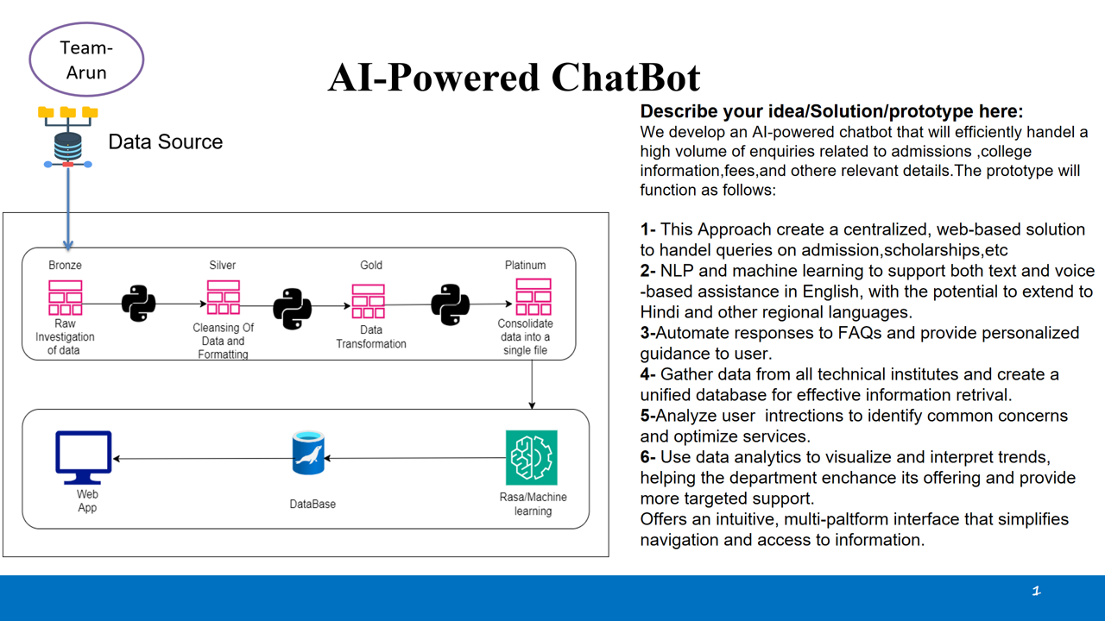
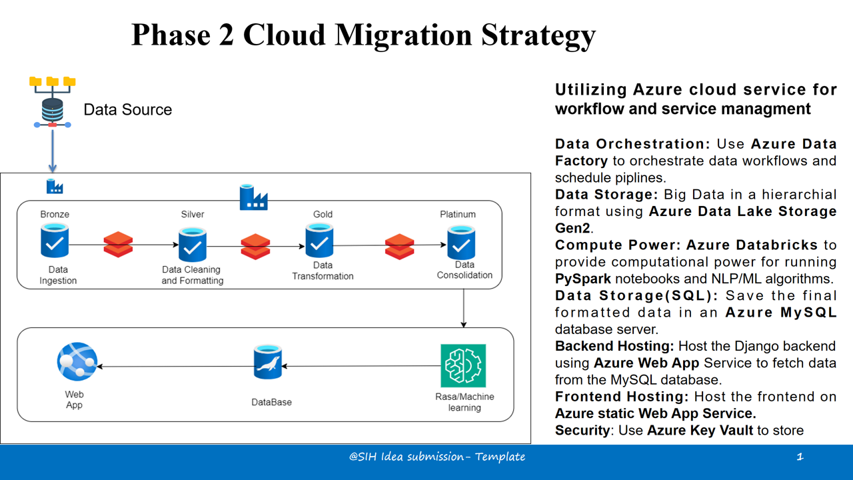

My System is not much capable and I try start some problem we can also add many other feature to enhance the chat bot like:-
1:-SpaCy & Hugging Face: Use libraries like SpaCy for efficient entity extraction, and Hugging Face's transformers library to access pre-trained models and improve the quality of language understanding.
2:-Rasa X: Integrate Rasa X for better conversation monitoring, feedback, and training of your chatbot. It provides a GUI interface for managing and improving conversations, which can make your bot smarter over time.
3:-Speech Recognition (STT): Add voice interaction using Google Speech-to-Text,

4:-Chatbot Analytics and Feedback Loops :- Analytic s Tools: Integrate analytics tools like BotPress Analytics, Google Analytics, or BotSociety to analyze user behavior, interaction trends, and find areas of improvement.
5:- We add many more function it like order booking, product list and many other functions.

6:- Integrate many other APIs to perfect and accurate response.

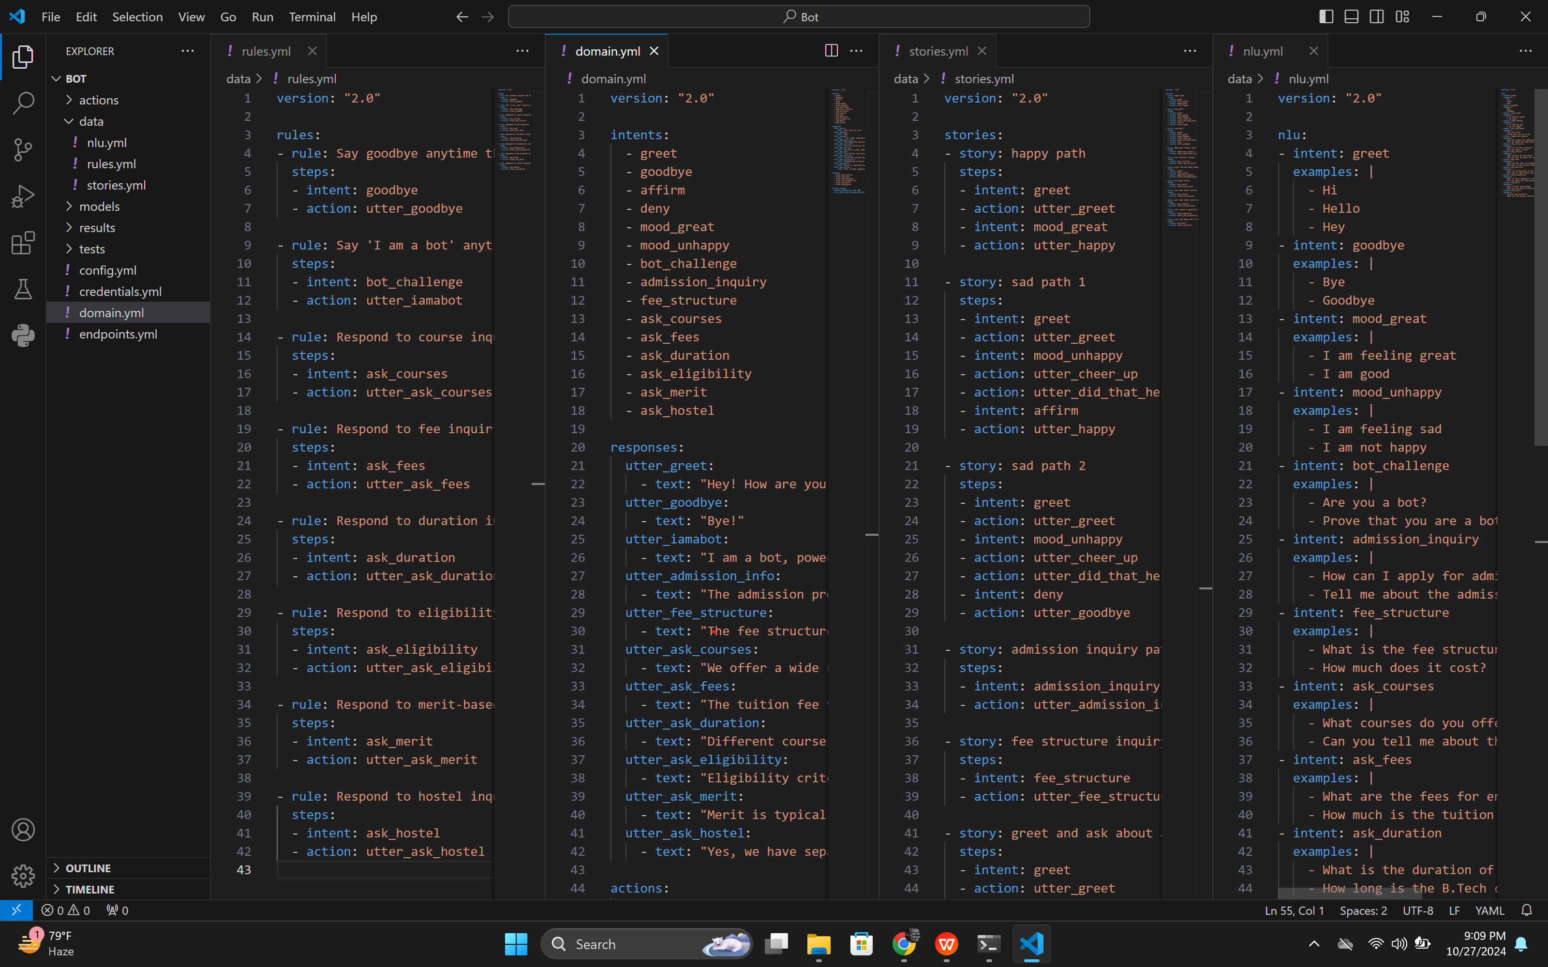
Outputs:-

FINANCIAL EQUATION
The global market for AI-powered chatbots has been expanding rapidly, with small and medium-sized businesses increasingly adopting automation to improve customer support. Given these trends, it would be feasible to price the chatbot service around Rs.10,000 for a three-month plan targeting small businesses, and Rs.15,000 for medium-sized businesses. With an increasing customer base, the subscription fees or service duration could be adjusted to optimize profitability.
Assumptions:
- Development Time: Estimated at 2-3 weeks.
- Team Composition: Includes one ML engineer and one full-stack developer, with salaries represented as ml and fs, respectively.
- Customer Growth Function: Represented as x(t)x(t)x(t), indicating the projected increase in the number of subscribers over time.

Financial Equation
Let:
- c=ml+fsc = ml + fsc=ml+fs: Total fixed cost for development.
- rrr: Revenue per customer (averaging Rs. 10,000 to Rs. 15,000 per three-month plan).
Then, the profit yyy as a function of customer growth over time, x(t)x(t)x(t), can be defined as:
y=r⋅x(t)−(ml+fs)y = r \cdot x(t) - (ml + fs)y=r⋅x(t)−(ml+fs)
Where:
- r⋅x(t)r \cdot x(t)r⋅x(t): Total revenue generated from customers.
- (ml+fs)(ml + fs)(ml+fs): Fixed costs for initial development.
Assuming a steady customer base increase, this model can be adjusted to forecast profit over different time intervals and potential scaling scenarios. As the customer base grows, the profit margin is expected to improve significantly beyond the initial development costs.

